Ideation Phase
Brainstorm & Idea Prioritization Template
Date | 8 March 2026
Team ID
Project Name | Avi-Luxe E-commerce Application
Maximum Marks | 4 Marks

Brainstorm & Idea Prioritization Template
Brainstorming provides a free and open environment that encourages everyone within a team to participate in the creative thinking process that leads to problem solving. Prioritizing volume over value, out-of-the-box ideas are welcome and built upon, and all participants are encouraged to collaborate, helping each other develop a rich amount of creative solutions.
Use this template in your own brainstorming sessions so your team can unleash their imagination and start shaping concepts even if you're not sitting in the same room.
Reference: https://www.mural.co/templates/brainstorm-and-idea-prioritization

Step 1: Team Gathering, Collaboration and Select the Problem Statement
Before you collaborate (10 minutes)
A little bit of preparation goes a long way with this session. Complete the following before the team gathers:
A. Team Gathering — Define who should participate in the session and send an invite. Share relevant information or pre-work ahead.
B. Set the Goal — Think about the problem you'll be focusing on solving in the brainstorming session.
C. Learn how to use the facilitation tools — Use Facilitation Superpowers to run a happy and productive session.

Team Composition — Avi-Luxe (AVK103)
Team Member | Role | Contribution Area | Pre-work / Knowledge | Sprint Focus | Session Time
Avinash (Lead) | Full-Stack Dev | Architecture, Auth, API design | React 19, Express 5, JWT, MongoDB | Sprint 1 — Core | 10 min
Avishakr chavan | Frontend Design | Theme, layout, animations, accessibility | GSAP, Three.js, CSS, Figma wireframes | Sprint 1 — UI | 10 min
Avinash | Server & DB | Routes, controllers, security middleware | Node.js, bcryptjs, Mongoose schemas | Sprint 1 — API | 10 min
Avishkar chavan | Features & Scope | Cart, orders, admin, wishlist, roadmap | User stories, sprint planning, backlog | Sprint 2 — Features | 10 min
Avinash Karale | Quality & Testing | Input validation, error handling, edge cases | Postman, schema testing, Mongoose validation | Sprint 1–2 | 10 min
Avishkar chavan | Infra & Deployment | CI/CD, env config, cloud deploy, CORS | Vercel, Railway, MongoDB Atlas, dotenv | Sprint 2–3 | 10 min

Define your Problem Statement (5 minutes)
Frame the problem as a 'How Might We' statement. This will be the focus of the entire brainstorm session.

Problem Statement:
How might we (Avinash) build a premium luxury e-commerce experience for the Avi-Luxe brand that is visually immersive, fast to load, secure, and easy to maintain — enabling customers to discover and purchase fashion products seamlessly while giving administrators full control over the catalogue and orders?

Key Rules of Brainstorming
To run a smooth and productive session, all participants agree to follow these ground rules:
• Stay on topic — keep all ideas relevant to the problem statement
• Encourage wild ideas — no idea is too out-of-the-box at this stage
• Defer judgment — criticism and evaluation come after the brainstorm, not during
• Listen to others — build on each other's ideas rather than dismissing them
• Go for volume — generate as many ideas as possible in the time available
• If possible, be visual — sketches, diagrams and sticky notes are encouraged

Step 2: Brainstorm, Idea Listing and Grouping
2A — Brainstorm (10 minutes)
Each team member writes down all ideas that come to mind addressing the problem statement. Ideas are placed on individual sticky notes — one idea per note. No filtering at this stage; all ideas are valid.

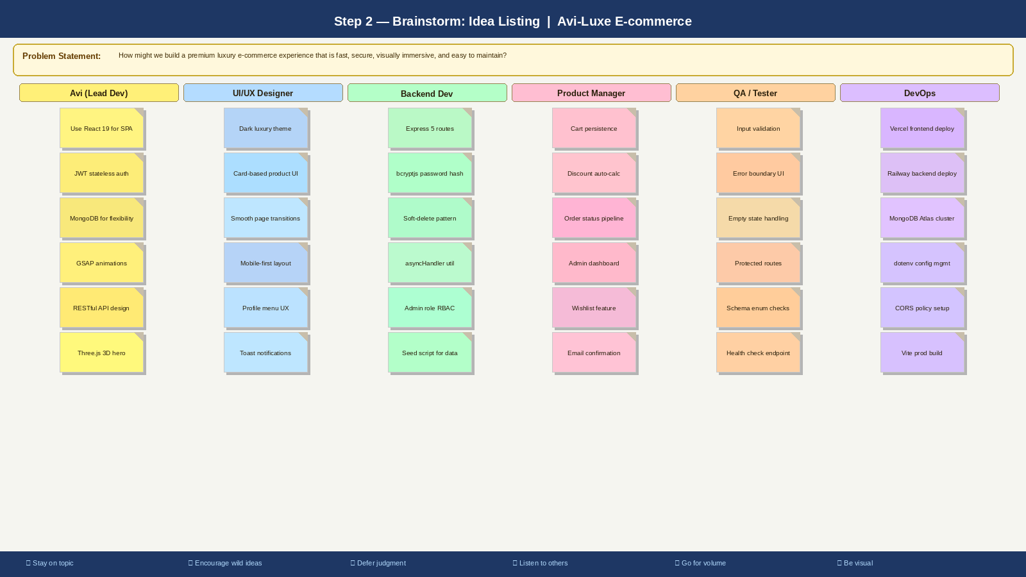

The diagram above shows sticky notes from all 6 team members (Avi, UI/UX Designer, Backend Dev, Product Manager, QA/Tester, DevOps), each contributing 6 ideas colour-coded by team role.

2B — Group Ideas by Theme (20 minutes)
Take turns sharing ideas while clustering similar or related notes together. Give each cluster a sentence-like label. If a cluster is larger than 6 sticky notes, break it into smaller sub-groups. The diagram below shows the 6 affinity groups for Avi-Luxe:

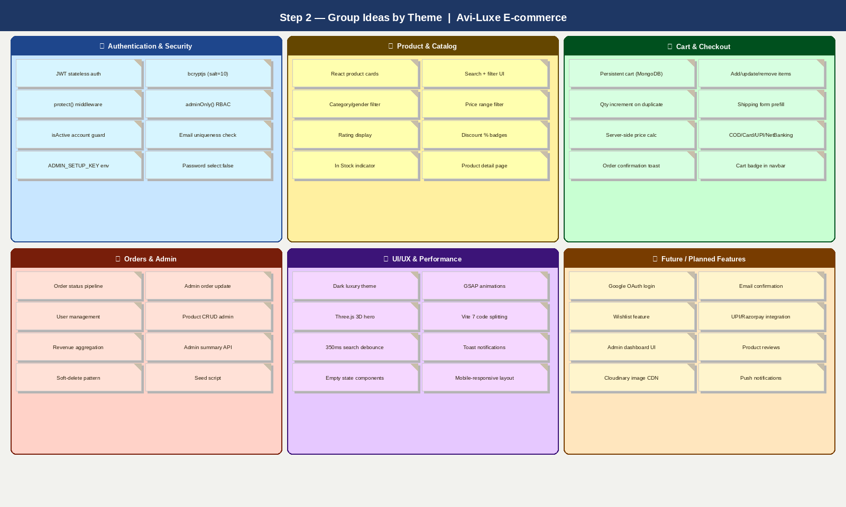

Six theme groups emerged from the clustering exercise:
• Authentication & Security — 8 ideas around JWT, bcryptjs, RBAC, account protection
• Product & Catalog — 8 ideas around browsing, searching, filtering, and product detail
• Cart & Checkout — 8 ideas around persistent cart, server-side pricing, payment methods
• Orders & Admin — 8 ideas around order lifecycle, admin controls, data management
• UI/UX & Performance — 8 ideas around animations, theming, responsive design, speed
• Future / Planned Features — 8 ideas for Sprint 2+ (OAuth, email, wishlist, reviews, payments)

Idea Listing Table
The following table lists all 18 brainstormed ideas with their theme group, implementation hint, and rationale for inclusion in the product backlog:

ID | Idea / Feature | Theme Group | Implementation Hint | Rationale
ID-01 | JWT stateless authentication (register + login) | Auth & Security | React useAuth hook + Express protect() | Eliminates server-side session management; scales horizontally; JWT token persists login state client-side; bcryptjs prevents password exposure even if DB is breached
ID-02 | Role-based access control — User vs Admin | Auth & Security | adminOnly() middleware + role field in User model | Enables separate customer and admin workflows from a single codebase; easy to extend to additional roles (vendor, support)
ID-03 | Soft-delete with isActive flag (users & products) | Auth & Security | isActive:false in Mongoose schema | Preserves historical order and cart data; admin can re-activate products without data loss; industry standard for e-commerce
ID-04 | Product catalog with search + multi-filter | Product & Catalog | React ShopPage + /api/products query params | Core shopping feature; server-side filtering reduces payload; 350ms debounce reduces API load; regex search is flexible
ID-05 | Product detail page with image carousel | Product & Catalog | ProductDetailsPage + product.carousel[] array | Increases purchase confidence; fashion shoppers expect multiple angles; drives conversion rate
ID-06 | Cart with persistence across sessions (MongoDB) | Cart & Checkout | CartPage + /api/cart · useCart() hook | Prevents cart loss on page refresh or device switch; standard expectation for premium e-commerce
ID-07 | Server-side price calculation at checkout | Cart & Checkout | orderController — subtotal/discount/total computed | Prevents client-side price manipulation; discounts applied per-product from DB; trust signal for premium brand
ID-08 | Order status pipeline (5 states) | Orders & Admin | Order.status enum: pending→confirmed→shipped→delivered→cancelled | Complete order lifecycle management; customers can track orders; admin can update status from dashboard
ID-09 | Admin product CRUD + inventory management | Orders & Admin | Admin routes /api/admin + /api/products (POST/PUT/DELETE) | Enables team to manage catalogue without developer intervention; soft-delete keeps orders intact
ID-10 | GSAP animations + Three.js 3D hero scene | UI/UX & Performance | HomePage + GSAP timeline + @react-three/fiber canvas | Differentiates Avi-Luxe from generic e-commerce; GPU-accelerated animations maintain 60fps; builds premium brand perception
ID-11 | Dark luxury UI theme (mobile-responsive) | UI/UX & Performance | Tailwind-style CSS + dark colour palette + React Router v6 | Consistent with luxury fashion branding; mobile-first ensures broad device support; brand identity in every interaction
ID-12 | Vite 7 build optimisation + 350ms debounce | UI/UX & Performance | vite.config.js + setTimeout debounce in ShopPage | Code splitting reduces initial load; debounce cuts API calls per keystroke by ~70%; fast load is critical for conversion
ID-13 | Google OAuth / Facebook Login | Future Features | Passport.js + passport-google-oauth20 (planned Sprint 2) | Reduces registration friction; OAuth users convert at higher rates; industry standard for modern apps
ID-14 | Email confirmation + order receipts | Future Features | Nodemailer + SendGrid (planned Sprint 2) | Increases registration trust; order email is a basic e-commerce expectation; legal requirement in some regions
ID-15 | Wishlist feature | Future Features | New Wishlist model + /api/wishlist routes (planned Sprint 2) | Increases return visits; users bookmark items for later; feeds into personalised recommendation future work
ID-16 | Product reviews and ratings submission | Future Features | New Review route + product.ratingsCount update (planned Sprint 2) | Builds social proof; schema already has rating/ratingsCount fields ready; drives purchase confidence
ID-17 | Razorpay/Stripe payment integration | Future Features | Razorpay SDK + Order paymentMethod enum (planned Sprint 3) | Enables real transactions; COD is limiting for digital-first brand; card/UPI/netbanking enum already in Order model
ID-18 | Admin dashboard UI (frontend) | Future Features | New AdminPage in client/src/pages/ (planned Sprint 2) | Server APIs exist; admin needs visual interface; revenue charts, order table, user list

Step 3: Idea Prioritization (20 minutes)
Prioritization Framework
Your team should all be on the same page about what is important moving forward. Place ideas on the Impact × Feasibility grid to determine which ideas are important and which are feasible. The four quadrants are:
• DO FIRST (High Impact + High Feasibility) — These are the ideas we implement in Sprint 1. They deliver the most user value and are achievable within our current skill set and timeline.
• INVEST (High Impact + Low Feasibility) — These ideas are important but require more effort, dependencies, or planning. Scheduled for Sprint 2 and Sprint 3.
• QUICK WINS (Low Impact + High Feasibility) — Easy to implement and improve developer experience or system reliability. Picked up alongside Sprint 1 features.
• DEPRIORITIZE (Low Impact + Low Feasibility) — These ideas are creative but not aligned with the current project scope or team capability. Deferred to Sprint 3+.

Idea Prioritization Matrix Diagram
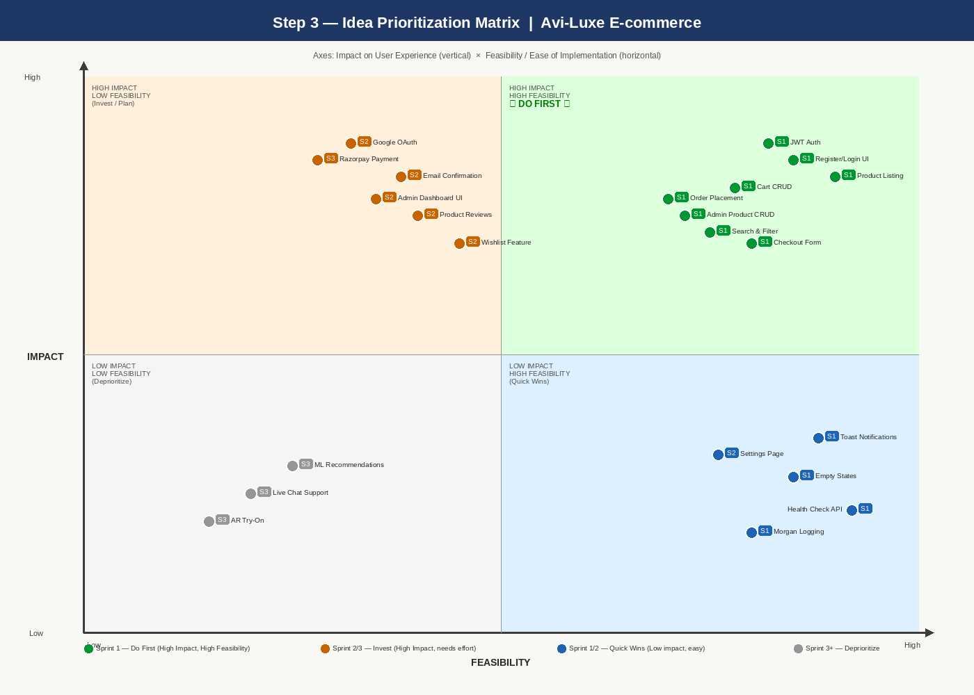

Each dot on the matrix represents a feature idea. The Sprint label (S1/S2/S3) indicates which sprint the team commits to delivering that feature. The top-right green quadrant (DO FIRST) contains all 12 Sprint 1 core features.

Idea Prioritization Table
The following table formalises the prioritization outcome, including quadrant assignment, impact score, feasibility score, and sprint allocation:

ID | Idea / Feature | Quadrant | Impact | Feasibility | Sprint
ID-01 | JWT Auth + Register/Login | DO FIRST | High | High | Sprint 1
ID-04 | Product Catalog + Search | DO FIRST | High | High | Sprint 1
ID-06 | Cart with MongoDB Persistence | DO FIRST | High | High | Sprint 1
ID-07 | Server-side Price Calculation | DO FIRST | High | High | Sprint 1
ID-08 | Order Status Pipeline | DO FIRST | High | High | Sprint 1
ID-09 | Admin Product CRUD | DO FIRST | High | High | Sprint 1
ID-10 | GSAP + Three.js Hero | DO FIRST | High | High | Sprint 1
ID-11 | Dark Luxury UI Theme | DO FIRST | High | High | Sprint 1
ID-12 | Vite 7 + Debounce | DO FIRST | High | High | Sprint 1
ID-02 | Role-Based Access Control | DO FIRST | High | High | Sprint 1
ID-03 | Soft-Delete (isActive) | DO FIRST | High | High | Sprint 1
ID-05 | Product Detail + Carousel | DO FIRST | High | High | Sprint 1
ID-13 | Google OAuth Login | INVEST | High | Medium | Sprint 2
ID-14 | Email Confirmation | INVEST | High | Medium | Sprint 2
ID-15 | Wishlist Feature | INVEST | High | Medium | Sprint 2
ID-16 | Product Reviews | INVEST | High | Medium | Sprint 2
ID-18 | Admin Dashboard UI | INVEST | High | Medium | Sprint 2
ID-17 | Razorpay/Stripe Payment | INVEST | High | Low | Sprint 3
ID-19 | Toast Notifications | QUICK WIN | Low | High | Sprint 1
ID-20 | Empty State Components | QUICK WIN | Low | High | Sprint 1
ID-21 | Health Check API | QUICK WIN | Low | High | Sprint 1
ID-22 | Morgan HTTP Logging | QUICK WIN | Low | High | Sprint 1
ID-23 | Settings Page Toggles | QUICK WIN | Low | High | Sprint 2
ID-24 | ML Recommendations | DEPRIORITIZE | Low | Low | Sprint 3+
ID-25 | AR Try-On Feature | DEPRIORITIZE | Low | Low | Sprint 3+
ID-26 | Live Chat Support | DEPRIORITIZE | Low | Low | Sprint 3+

Prioritization Outcome & Sprint Plan
Based on the Impact × Feasibility prioritization exercise, the team aligned on the following sprint plan for the Avi-Luxe E-commerce Application:

Sprint 1 — Core Platform (DO FIRST)
12 features committed to Sprint 1. These form the minimum viable product (MVP) of Avi-Luxe:
• Authentication: JWT register/login, bcryptjs hashing, protect/adminOnly middleware, soft-delete
• Product Catalog: Browse, search (regex), filter by category/gender/price, product detail with carousel
• Cart & Checkout: MongoDB-persisted cart, server-side price calculation, COD payment, order confirmation
• Admin: Product CRUD, order status updates, user management APIs
• UI/UX: Dark luxury theme, GSAP animations, Three.js 3D hero, mobile-responsive layout, Vite 7 build
• Quick Wins included: Toast notifications, empty states, health check endpoint, Morgan logging

Sprint 2 — Enhanced Features (INVEST + QUICK WINS)
6 features planned for Sprint 2, requiring additional design and backend work:
• Google OAuth 2.0 login integration (Passport.js)
• Email confirmation and order receipt emails (Nodemailer + SendGrid)
• Wishlist feature — new Wishlist model, routes, and UI
• Product reviews and ratings submission UI
• Admin Dashboard frontend page with summary stats and charts
• Settings page preference toggles (already scaffolded in Sprint 1)

Sprint 3 — Advanced Features
1 high-impact feature with significant external dependency:
• Razorpay / Stripe payment gateway integration — enabling real card, UPI, and NetBanking transactions
• ML-based product recommendations (deferred — low feasibility with current team capacity)

References
• MURAL Brainstorm & Idea Prioritization Template: https://www.mural.co/templates/brainstorm-and-idea-prioritization
• Project Repository: https://github.com/AVK103/Avi-Luxe__E-commerce-Application
• C4 Architecture Model: https://c4model.com/
• Impact vs Feasibility Matrix: https://www.nngroup.com/articles/prioritization-matrices/

